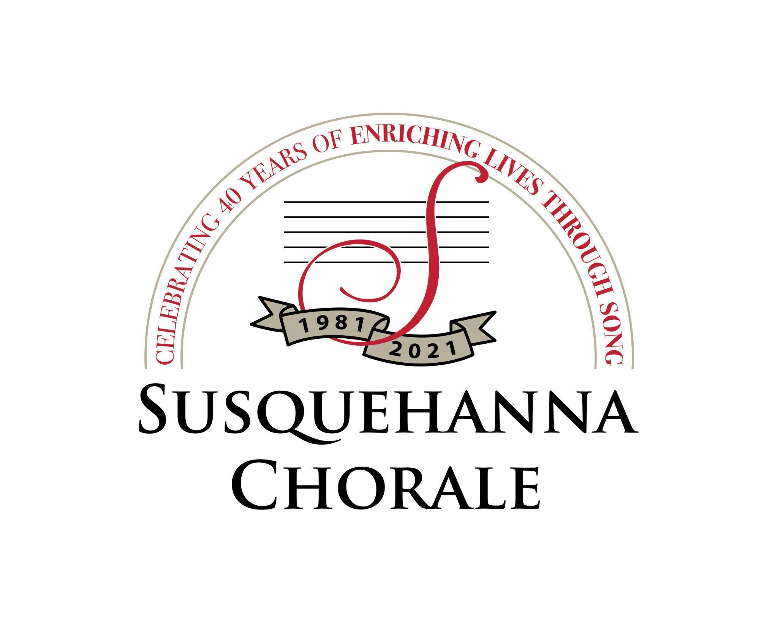
NEWS

Contact: Barry Kroeker,
Director of Marketing
marketing@susquehannachorale.org
(814)359-8597

Chorale’s 40th Anniversary Season Continues with Live May Concerts
MECHANICSBURG (February 15, 2022) – The Susquehanna Chorale is continuing its 40th Anniversary Legacy season in May with two live performances of their spring program entitled A Celebration in Song!
Performances are on Friday, May 13, 2022 at 8 p.m. at the Derry Presbyterian Church, Hershey; and Sunday, May 15, 2022 at 4 p.m. at the High Center, Messiah University, Mechanicsburg. Tickets for both may be purchased through the Messiah University Box Office, and audience members are invited to a reception following each performance. For more information, visit www.susquehannachorale.org/performances.
“Celebrate with us as we commemorate our legacy: 40 years of enriching lives through song,” said Artistic Director and Conductor Linda Tedford. “Experience our joy as we come together with renewed excitement for singing to an audience in live performance.”
The Susquehanna Chorale is a nationally acclaimed adult chamber ensemble of 37 auditioned singers. Since its founding by Tedford in 1981, the group has been praised for its “ethereal blend,” “unparalleled tone,” and strong emotional connection to the music.
The May concerts will feature songs that have delighted its listeners for four decades, including sacred motets, early American hymns, love songs, and African American spirituals. There are songs that reflect heartfelt faith, common experiences, and powerful emotions. Concert repertoire includes signature Chorale favorites like Schubert’s Holy, Holy, Holy and Bruckner’s Locus Iste; Philip Stopford’s poignant Do Not Be Afraid; two classic early American folk hymns, Down to the River to Pray and No Time; and Java Jive, made famous by Manhattan Transfer. The concert will conclude with Rollo Dilworth’s Shine the Heavenly Light, and a special performance of Shenandoah as the Susquehanna Chorale is joined by several alumni.
The Susquehanna Chorale is a recipient of Chorus America’s most prestigious award, the Margaret Hillis Achievement Award for Choral Excellence. Conductor Tedford was honored by the American Choral Directors Association of Pennsylvania with the Elaine Brown Award for lifelong commitment to excellence and leadership in the choral art. In 2013, she received Theatre Harrisburg’s Award for Distinguished Service to the Arts in the Capital Region. The Chorale is funded in part by the Pennsylvania Council on the Arts, a state agency funded by the Commonwealth of Pennsylvania.
# # #
Editor’s Note: Photo linked.

