NEWS

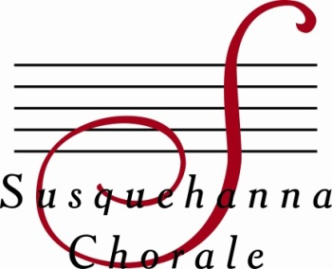
Contact: Katie Hammaker,
Director of Development and Marketing
717.796.5075 or dev@susquehannachorale.org

Enriching lives through song

Susquehanna Chorale Concerts to Honor Beethoven, Feature Songs that
Celebrate Human Strength and Determination

MECHANICSBURG (February 10, 2020) – The nationally-acclaimed Susquehanna Chorale will present its spring concert series, “Through Love to Light,” on May 8 and 9, 2020.

Artistic Director and Conductor Linda L. Tedford has designed a concert of music that celebrates the resilience and strength of the human spirit in song, crafted by some of today’s most exciting and innovative composers.

“These are stories that connect us and reflect our capacity to love and persevere, even in the face of adversity,” Conductor Tedford said. “I am particularly excited about the centerpiece of our performance: Jake Runestad’s A Silence Haunts Me, which invites us into the personal experience of Beethoven as he gradually loses his hearing. I find it especially meaningful to present this stunning piece in 2020, the 250th anniversary of Beethoven’s birth.”

Kim André Arnesen’s Even When He is Silent encourages hope in the darkest hour of life. The text for this piece was written by a World War II prisoner, who etched the words on the wall of his cell while being held at a concentration camp.

The concerts also will feature Eric Whitacre’s Goodnight Moon, Elaine Hagenberg’s Oh Love and Through Love to Light, Shawn Kirchner’s Sweet Rivers, and James Stevens’ arrangement of Nearer My God to Thee.

“I have chosen repertoire that speaks to a variety of emotions that Beethoven may have experienced, from frustration to exuberant joy,” Conductor Tedford said.

Performances are Friday, May 8, at Derry Presbyterian Church in Hershey, and Saturday, May 9, at the High Center for Performing Arts on the campus of Messiah College, Mechanicsburg, both beginning at 8 p.m.

Additionally, the May 9 performance from Messiah College will be available via livestream.

The Chorale is an award-winning adult chamber ensemble of 38 auditioned singers. Since its founding in 1981 by Ms. Tedford, the group’s audience members have consistently cited the Chorale’s “ethereal blend,” “unparalleled tone,” and emotional connection to the music.

Susquehanna Chorale Announces Spring Concerts
Page 2

The Chorale wishes to thank Fulton Private Bank, its 2019-20 season sponsor, and University Music Service of Hershey, the spring concert sponsor.

Tickets are available through the Chorale’s website, www.susquehannachorale.org, or by calling the Messiah College Box Office, 717.691.6036. Tickets are $22 in advance and $27 at the door for adults, and $5 for students. Discounts are available for groups of 10 or more if tickets are purchased in advance.

The Susquehanna Chorale is a recipient of Chorus America’s most prestigious award, the Margaret Hillis Achievement Award for Choral Excellence. In 2011, Conductor Tedford was honored by the American Choral Directors Association of Pennsylvania with the Elaine Brown Award for Choral Excellence in Pennsylvania. In 2013, she received Theatre Harrisburg’s Award for Distinguished Service to the Arts in the Capital Region. The Chorale is funded in part by the Cultural Enrichment Fund, the capital region’s united arts fund, and the Pa. Council on the Arts.

# # #

Editor’s Note: Photo Enclosed.

