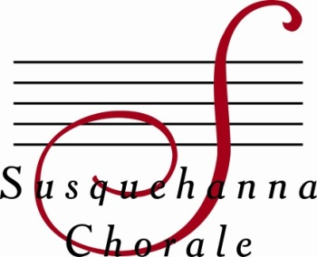
Contact: Katie Hammaker
Telephone: (717) 796-5075
Email: dev@susquehannachorale.org

Enriching lives through song

Susquehanna Chorale Returns to Mt. Gretna on Aug. 19

Mechanicsburg, PA (July 23, 2018) - The critically acclaimed Susquehanna Chorale will perform “Music for a Summer’s Evening” at Mt. Gretna’s open-air Tabernacle on Sunday, Aug. 19, at 7:00 p.m. The Chorale’s founder and artistic director, Linda L. Tedford, will conduct the Chorale in its appearance as part of Mt. Gretna’s Summer at the Tabernacle concert series.

The Susquehanna Chorale, founded in 1981, is a nationally-recognized adult chamber ensemble of 38 singers, chosen by audition. It has been cited by critics and audiences alike for its “velvet” blend, its precision, versatility, and ability to communicate emotionally with its audiences.

“We always look forward to singing in the Tabernacle,” Tedford said. “An open-air concert on a warm summer night makes for a very special experience. We have been part of this series for many years, and we love performing for the wonderful Gretna audience.”

“For this concert, I have selected music that celebrates our roots, the things that give us stability,” Tedford continued. “It is these roots - spiritual, relational and musical - that give us wings, the ability to stand secure in our foundation, and then encourage us to dream, to feel, and to be inspired to express ourselves.”

The concert begins with songs that celebrate faith and historical roots, including Fauré’s Cantique de Jean Racine, American spirituals, and Rhonda Sandberg’s modern arrangement of Bach’s Come, Sweet Death.

The modern lullaby Jenny Rebecca, Bob Chilcott’s setting of Christina Rosetti’s poem “Remember Me,” and Ēriks Ešenvald’s setting of Sara Teasdale’s “Only in Sleep” speak of the experience of looking back at our earliest or most important passages.

Songs from early America conclude the concert. Among them are selections from Copland’s “Old American Songs,” and Shawn Kirchner’s Unclouded Day.

Admission is without charge; a free-will offering to support the Tabernacle’s summer series will be collected. The Tabernacle is located at Third Street and Glossbrenner Avenue, Mt. Gretna (the Campmeeting side of Mt. Gretna).

For more information call 717-533-7859 or visit susquehannachorale.org. For parking information, see “Directions” at www.mtgretnatabernacle.org.

Ensemble-in-Residence at Messiah College, the Susquehanna Chorale is known for its commitment to artistic and expressive performance of a wide-ranging repertoire. It was awarded Chorus America’s most prestigious award, the Margaret Hillis Achievement Award for Choral Excellence. In 2011, Conductor Tedford was honored by the American Choral Directors Association of Pennsylvania with the Elaine Brown Award for lifelong commitment to excellence and leadership in the choral art. In 2013, she received Theatre Harrisburg’s Award for Distinguished Service to the Arts in the Capital Region. The Chorale is funded, in part, by the Cultural Enrichment Fund, the capital region’s united arts fund, and the Pennsylvania Council on the Arts.

# # #

Editor’s Note: Photo Enclosed.

