Welcome to the latest eNEWS from the PMEA Retired Member Network... an informal alliance and forum for interconnecting retired music educators and sharing their ideas, stories, successes, news, and views via this e-mail address. Thanks for contributing to and staying involved in PMEA and our profession!
More Details About the Summer PMEA Conference!
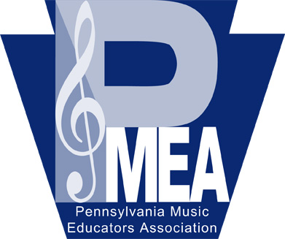
Keep an eye for updates on the upcoming PMEA Summer Conference from Assistant Executive Director Abigail Young. In our last eNEWS, we reminded you that summer professional development workshops will be offered on July 14-15 at the Holiday Inn Harrisburg East, featuring keynote speaker Johanna Seibert, Director of Fine Arts, Webster Central School District. Clinicians Sharon Potter, Chair of PMEA Model Curriculum Committee, and Scott Sheehan, Hollidaysburg Area SD, will present an overview of the PMEA Crosswalk Document, which will clarify how the PA Standards and Standards Aligned System, New National Standards, Former National Standards, and other relevant resources relate to one another. This will provide assistance to all music educators currently designing curriculum, instruction, and assessments.
Several breakout sessions look interesting, especially for retirees! Both Travis Weller (band) and Carl Barr (choral) are planning reading sessions during their clinics: Selecting Choral Repertoire for Effective Instruction and Even Ensemble Directors need PRACTICE! Other mini-workshop titles include Go ALL IN for Success, Music, Instruments and Legends of Asia and the Silk Road Trade Route, QR Code Technology in Music Education, Teaching Beyond the Concert, Google Apps for Music Education: Tracking Growth with ePortfolios, and Beginning Basics for Your Back Pocket (strings).
Because this event is heavily subsidized, the cost for the Summer Conference is $50 per attendee (full active, collegiate or retired). However, here’s some good news. It includes all sessions plus lunch and dinner on Tuesday and breakfast and a boxed lunch on Wednesday! Did someone say FOOD? For more details or to register, please go to the PMEA website: http://www.pmea.net/2015-pmea-summer-conference/.
Interesting in Helping PMEA – R³ and the Spring Conference?
There’s still time to volunteer and assist in the planning of the PMEA Spring Conference, which will be held March 31-April 2, 2016 at the Hershey Lodge and Convention Center. If interested, please contact Abigail Young directly at abiyoung@pmea.net.
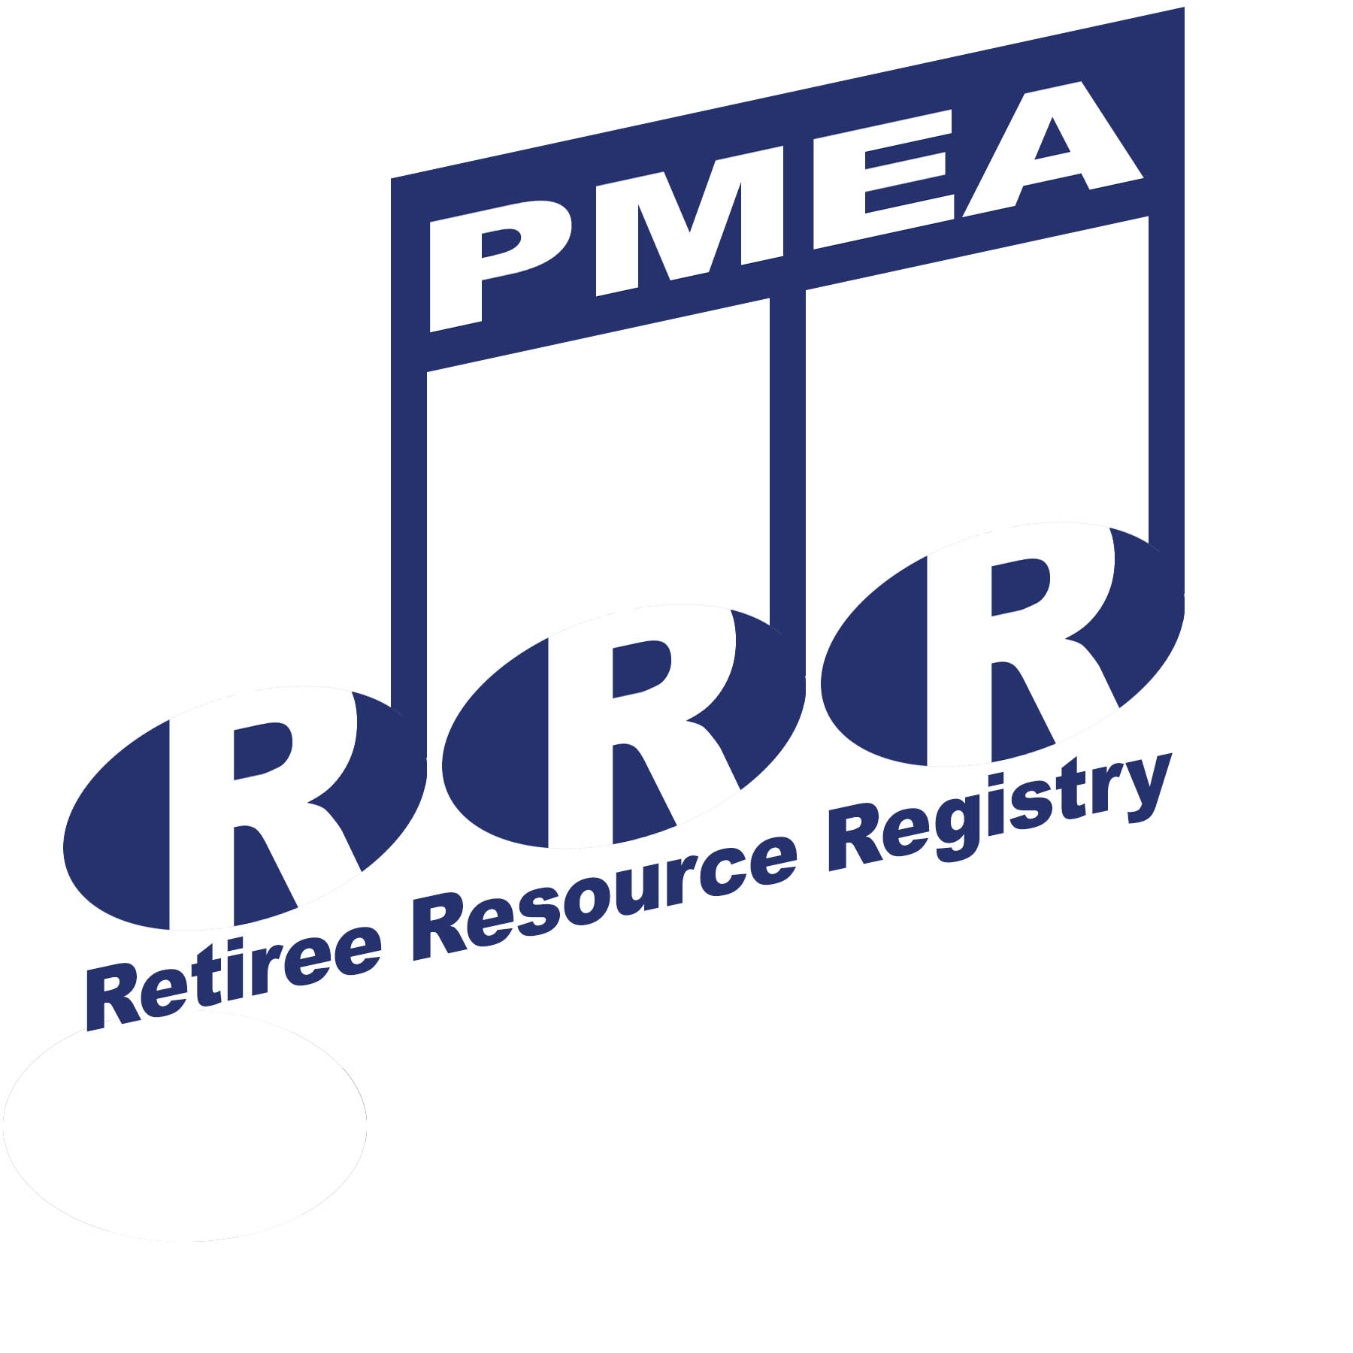
If you are willing to remain active in the profession and become an informal adviser to help other members, sign-up online for the Retiree Resource Registry (R³). Complete the online survey at https://pmea.wufoo.com/forms/pmea-retiree-resource-survey/.
We welcome our newest retired members soon-to-be-added to this service: James Falvo, Paul Gerlach, and Bret Mascaro! The “plan” is to totally revise both the registry and R³ Help Index by July 1.
Nag-Nag-Nag!
It’s that time of the year! Here’s a “friendly reminder” for everyone to “re-up” our PMEA annual membership, and what a discount! Retired members pay only $63 for PMEA/NAfME (as opposed to the Full Active rate of $132) or $30 for PMEA-Only. For more information, please go to http://www.pmea.net/membership-information/.
Updated List of PA Community Bands and Orchestras
The retired member article “Dust Off Your Chops…” in the fall edition of PMEA News is focused on “what is good for you” as well as “fun” in playing in a community instrumental ensemble. The feature will list over 155 groups available for the participation of our retirees and active members as well! Want a head start to get involved? Recently updated lists of Pennsylvania adult bands and orchestras, sorted both by city and ensemble’s name, are posted on the retired members’ section of the PMEA website: http://www.pmea.net/retired-members/. Please check back often to this site for all kinds of news, resources, and past issues of eNEWS.
Happy trails, retirees! Enjoy the summer months! Let’s hear from YOU! Keep in touch: paulkfox.usc@gmail.com. PKF

